**Demo Guide**

CIS 422

**Team 4**

**Zachary Bower, Chase Craig, Linshu Huang, Benjamin Yin, Luyao Wang**

**1. Demo-1 A rotating Box 2**

**1.1 Introduction 2**

**1.2 Demo display 2**

**2. Demo-2 A static pizza man and his box 5**

**2.1 Introduction 5**

**2.2 Demo display 5**

**1. Demo 0.1 ---------- A Rotating Box**

**1.1 Introduction**

This demo shows our Panda Engine can do the basic functionality, such as create a window, display the rotated object, pause the object status, restart the object status, and quit the program.

**1.2 Demo Display**

Run the demo, you need to satisfied with the [Prerequisites](https://docs.google.com/document/d/1-DKFmecn8fAYTDddtEsXq87vIHSOzJVQIl15kWUTk1Y/edit#heading=h.n3g4ukvxzjhy). For more information, check our user guide: <https://docs.google.com/document/d/1-DKFmecn8fAYTDddtEsXq87vIHSOzJVQIl15kWUTk1Y/edit>

**1.2.1 Display Rotated Cube with a green background**



**The user needs to press these buttons on the keyboard to manipulate the**

**Cube:**



**1.2.2 Press D to pause the rotation of the Cube**



**1.2.3 Press E to restart the rotation of the cube**



**1.2.4 Press Q to quit the program**

**2. Demo 2.0 ---------- A Static Pizza Man and His Box**

**1.Introduction**

This demo shows more functionality of the game engine. This demo creates and renders two objects with two different textures. The demo shows a full 360-degree field of view. The program utilizes both keyboard and mouse event handlers to achieve this movement.

**1.2 Demo Display**

Run the demo, you need to satisfied with the [Prerequisites](https://docs.google.com/document/d/1-DKFmecn8fAYTDddtEsXq87vIHSOzJVQIl15kWUTk1Y/edit#heading=h.n3g4ukvxzjhy). For more information, check our user guide: <https://docs.google.com/document/d/1-DKFmecn8fAYTDddtEsXq87vIHSOzJVQIl15kWUTk1Y/edit>

**1.2.1 Our script starts with display the rendering object with a green background.**



**1.2.1 Our script interacts with mouse event to move the camera and find the Pizza man. It also moves the Pizza man *further away* from the camera which is the user’s view by pressing:**



**Screen View:**

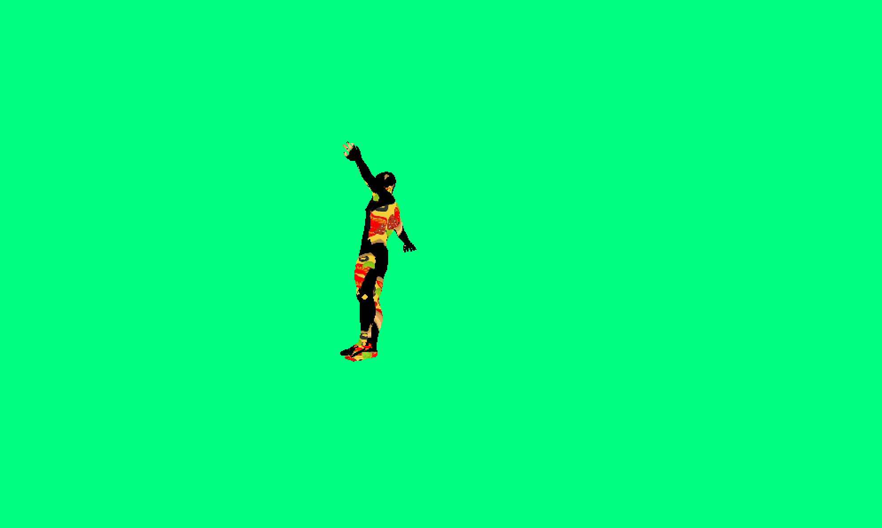

**1.2.2 Our script will interact with mouse event to move the camera and find the Pizza man. It moves the Pizza man close to the camera which is the user’s view by pressing:**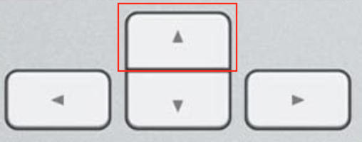

**Screen View:**

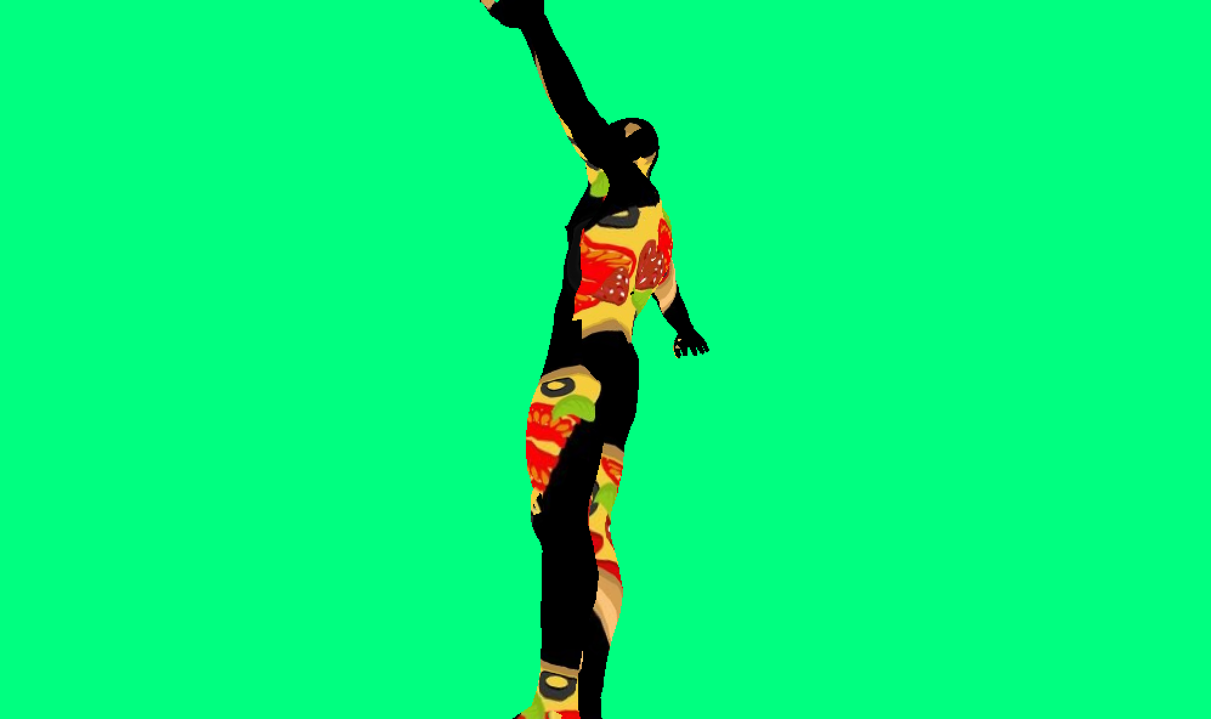

**1.2.3 Our script could interact with keyboard and mouse events together to move the Pizza Man. Move the objects to the left of the screen by pressing:**



**Screen View:**



**1.2.4 Our script could interact with keyboard and mouse event together to move the Pizza Man and box. Move the objects to the right of the screen by pressing:**



**Screen View:**



**1.2.5 Press “Q” to quit/close screen**